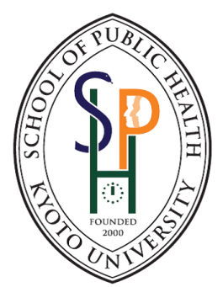
Document checklist: Application for
Double Master Degree Program for Public Health 2018
School of Public Health, Graduate School of Medicine
Kyoto University

Required documents
- Completed application form 1
- Completed application form 2
- Completed application form 3
- Curriculum Vitae/ Resume
- English Transcript of Bachelor’s degree (or other previous graduate degrees if any)
- English Certificate of Graduation of Bachelor’s degree (or other previous graduate degrees if any)
- English Certificate of Enrollment or Registration of the current Master’s degree at home university. The document should clearly
1. certify that you are currently a Master’s degree student of your home university
2. clearly state the date of enrollment for the current Master’s degree
3. clearly state the date of expected completion the current Master’s degree
4. clearly state the program that you are currently enrolled
- English transcript of the current Master’s degree at home university, if applicable
- Valid TOEFL iBT 80 or equivalent scores in IELTS
- For applicant with medical background: Professional License of medical doctor, nurse, pharmacist, etc.
Additional documents
- Letter of recommendation from CURRENT supervisor, employer, etc.
- Any academic award or related documents that may help strengthen your candidacy

Any questions or queries, contact:-
Teeranee Techasrivichien, PhD
Assistant Professor
Kyoto University School of Public Health (International Office)
techasrivichien.teeranee.2a [at] kyoto-u.ac.jp
Tel: +81 75 753 4350

